**COSC 365 Assignment #1 – Basic HTML**

**Dr. T. Fries Due: Monday, January 31, 2022**

Create the HTML file named pie.html that displays the recipe page shown below:

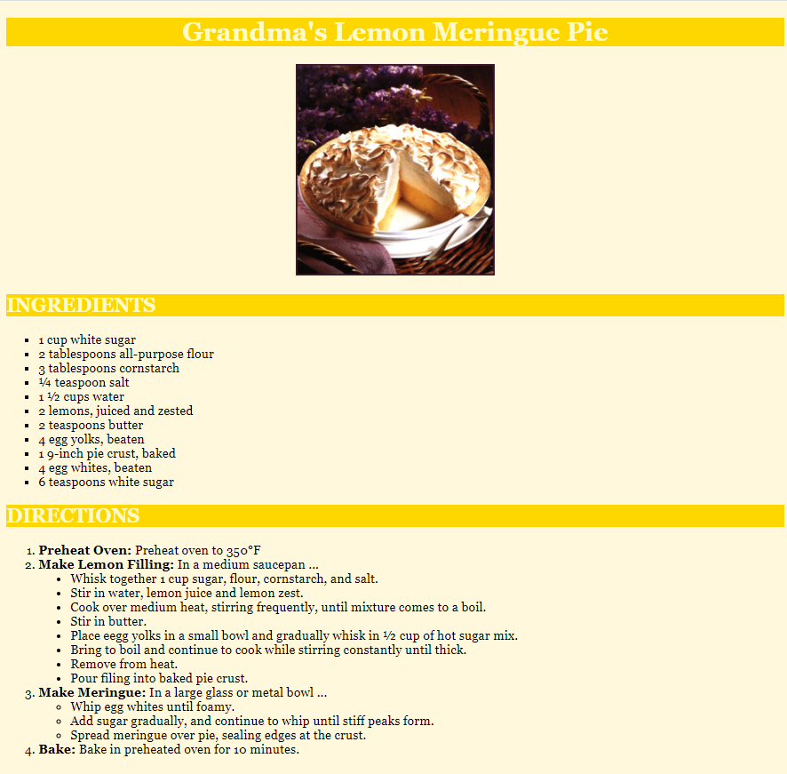

Recreate the web page describing a recipe for lemon meringue pie, stored in a file named pie.html. The page has a background color of cornsilk. The font families for the page are Georgia, 'Times New Roman', Times, serif.

The pie image is stored at images/pie.jpg. The picture of the pie is centered on the page.

All headings on the page should use a text color of lemonchiffon and a background color of gold. The page's main heading is h1 and aligned to the center of the page body. Other headings are h2 and left-aligned.

The names of the four major steps of the recipe directions (such as "Preheat Oven") are formatted in a strong font. The measurement ½ and ¼ in the Ingredients section use HTML special characters, as does the degree symbol in step 1 of the Directions. Use Google to find the correct HTML character codes.

The bullets in the ingredients list are squares and the bullets in step 2 of the directions are solid discs.

The pie web page's title text should be **Grandma's Lemon Meringue Pie**

### Deliverables:

1. Submit your zip file named pie.html via Moodle. Do not submit the picture; I will have it in the images folder when I test your assignment.